Collagen-µGel Composites for 3D Bioprinting
3D bioprinting has the potential to deliver patient specific engineered living tissue in the context of auricular cartilage reconstruction. However, the performance of these engineered tissues is limited by the poor mechanical properties of collagen hydrogels. Zwitterionic microgels have the potential to improve the pre- and post-gelation mechanics of collagen biomaterials through ionic crosslinking to charged amino acids on collagen chains.
This project builds on prior work with Dr. Jason Spector, Chief of Plastic Surgery at Weill Cornell Medical College, to develop auricular cartilage replacements. Successful design and characterization of collagen-µgel composites would be followed by in vitro evaluation to determine cellular compatibility, forming the basis for potential in vivo evaluation.
Students working on this project will be tasked either with:
Synthesizing zwitterionic µgels with varying composition and size distribution, analyzing µgel morphology via scanning electron microscopy, and evaluating the rheological properties of collagen-µgel composite gels, or
Seeding collagen-µgel composites with primary auricular chondrocytes with subsequent evaluation of constructs for cell viability, extracellular matrix deposition, and tensile mechanics.
This project is well suited for 1 student with a background in biomaterials, organic chemistry, polymer science, or soft materials, and 1 student with a background in biomaterials, tissue engineering, or biomechanics. Interested students should forward a copy of a resume and unofficial transcript to:
Contact: Prof. Larry Bonassar
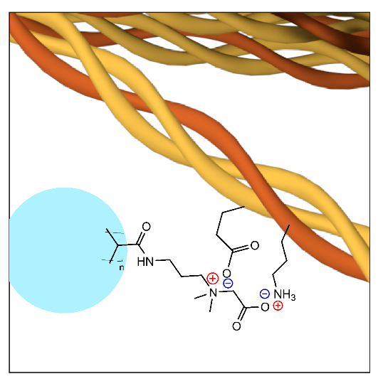
Email: lb244@cornell.edu
Phone: 5-9381
Office: 149 Weill Hall

