Creating Novel Software in LabView to Automate In-Line Data Collection during Bioprinting
Bioprinting uses bioink infused with cells to produce biocompatible constructs for tissue regeneration. However, little is known about the bioprinted constructs post-printing, and determination of cellular properties is cost and labor intensive, requiring the destruction of the construct for experimental testing. To reduce the drain on resources caused by this testing, we seek to non-destructively determine cellular properties during bioprinting with a custom software that communicates using LabView, a Digilent Analog Discovery 2 (AD2) device, and our custom syringe device.
The Bonassar Lab, with over a decade of bioprinting expertise, is in collaboration with West Pharmaceutical Services to develop an automated system capable of non-destructively analyzing cellular properties of constructs.
This project involves (1) creating custom software in LabView, (2) wiring the AD2 to a breadboard, (3) creating a frequency generator, impedance analyzer, and data analysis system and (4) testing the software using the smart syringe and bioprinter. During this project, the student will also learn how to operate the bioprinter, plan experiments and run an experiment.
This project is suitable for a student interested in software development, LabView or bioprinting. No prior experience is required, but experience in mechatronics (or similar hands-on courses) and LabView is helpful. The student will be trained by a graduate student and is expected to complete the project in 1 year.
Contact: Prof. L.J. Bonassar
Email: lb244@cornell.edu
Office: 149 Weill Hall
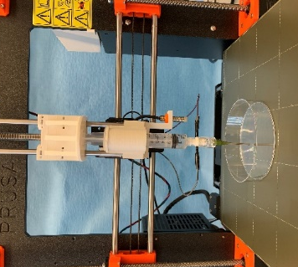

(Left) Bioprinter fitted with the smart syringe.

(Right) Sample of LabView software using graphical programming.

