Efficacy of Novel Cartilage Lubricants for Arthritis Treatment
Affecting more than 30 million people in the US, osteoarthritis (OA) is the leading cause of disability in the developed world. Proper lubrication of articular cartilage is essential to joint health. In healthy joints, the two molecules responsible for efficient cartilage lubrication are hyaluronic acid (HA) and lubricin. However, in arthritic joints or after traumatic injury, these molecules are degraded by enzymes and their ability to lubricate cartilage decreases drastically. This loss in lubrication can contribute to increased cartilage damage due to wear and is characterized by a high coefficient of friction. Our lab studies these cartilage lubrication mechanisms and characterizes lubrication therapies for treating OA. We have a custom-built friction measuring instrument known as the tribometer, which can be used to characterize cartilage lubricated in a wide variety of clinically relevant lubricants.
The Bonassar Lab (BME/MAE/MSE) in collaboration with Drs. Heidi Reesink (College of Veterinary Medicine) and Matthew Paszek (CBE) are interested in the characterization and optimization of a novel, bioengineered cartilage lubricant. This bioengineered molecule has been carefully produced to mimic the structure of lubricin, the protein crucial to cartilage lubrication. Identifying the key mechanisms by which this novel material lubricates cartilage in situ would accelerate the process of moving this therapy to the clinic.
Students who join the team will be tasked with: characterizing the lubricating behavior of intact and enzymatically degraded bioengineered lubricin with cartilage tissue samples; and identifying the optimal formulation of HA and bioengineered lubricin to lubricate cartilage effectively. Depending on the students’ interest and background, additional opportunities may exist to assess the efficacy and safety of these lubricants for in vivo studies.
This project is well suited for 1-2 students who have a background in biomechanics, biomaterials, or materials science. No prior experience is required but a working knowledge of mechanics, basic wet lab skills and MATLAB may prove useful. Interested students should forward a copy of a resume and unofficial transcript to:
Contact: Prof. Larry Bonassar
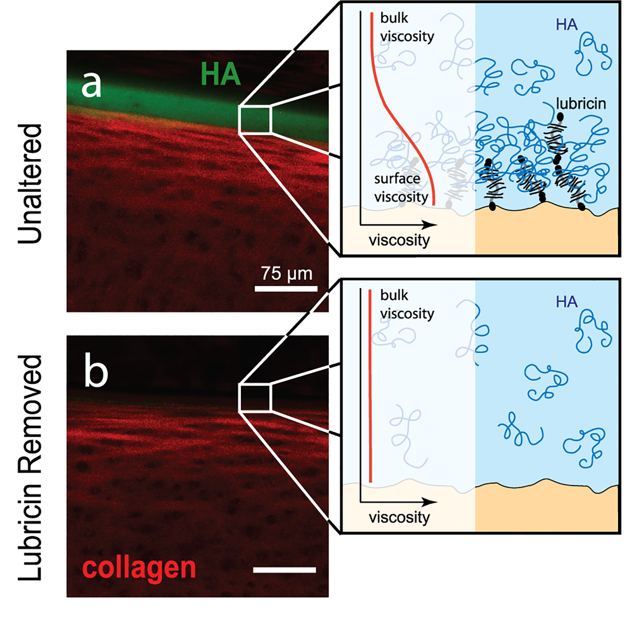
Email: lb244@cornell.edu
Phone: 5-9381
Office: 149 Weill Hall
