Hypoxic culture of fibrochondrocytes for improved maturation of tissue engineered meniscus
The menisci are fibrocartilage disks in the knee that act as shock absorbers and provide stabilization and facilitation of load transmission. Meniscus injuries are the most common pathology of the knee, and intrinsic repair is limited due to the lack of blood supply to the tissue. Therefore, a replacement option is needed. The spatiotemporal gradient in extracellular matrix (ECM) composition and cell phenotype facilitate meniscus function. Recapitulating the native structure and mechanical properties in tissue engineered systems is a challenge.
The Bonassar Lab (BME/MAE) is working on developing different techniques to improve the ECM structure and mechanical properties in tissue engineered meniscus constructs. A variety of biomechanical and biochemical stimulants have been used to improve this structure. Hypoxic culture conditions have been shown to boost meniscal cell maturation, stimulating cells to produce more ECM components than cells cultured under normoxic conditions. Applying hypoxic culture conditions to collagen gel-based tissue engineered constructs could help with tissue development and improve mechanical properties.
Students who join the team will be tasked with: developing a protocol to culture meniscal fibrochondrocytes in 2D culture under hypoxic conditions; testing these culture conditions on tissue engineered meniscus constructs; characterize the ECM content and mechanical properties of these constructs using biochemical analysis and mechanical testing. Depending on the students’ interest and background, additional opportunities may exist to further analyze these constructs using image analysis and histology. A student working on this project can expect to learn proper lab etiquette including lab safety, proper pipetting techniques, and proper maintenance of a lab notebook. The student will learn more specific techniques relating to the fundamentals of tissue engineering and cell culture including how to extract primary cells from tissue, cell culture maintenance, and production of tissue engineered menisci.
This project is well suited for a student who has a basic understanding of biology, the cell environment, and some basic laboratory experience (e.g. General Chemistry 1 and 2 Lab). Interested students should forward a copy of a resume and unofficial transcript to:
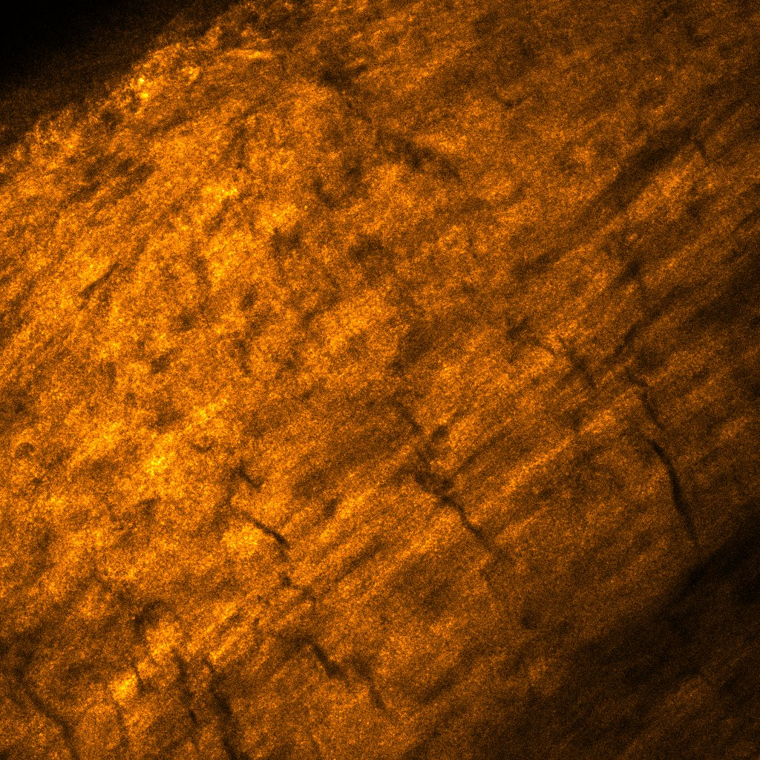
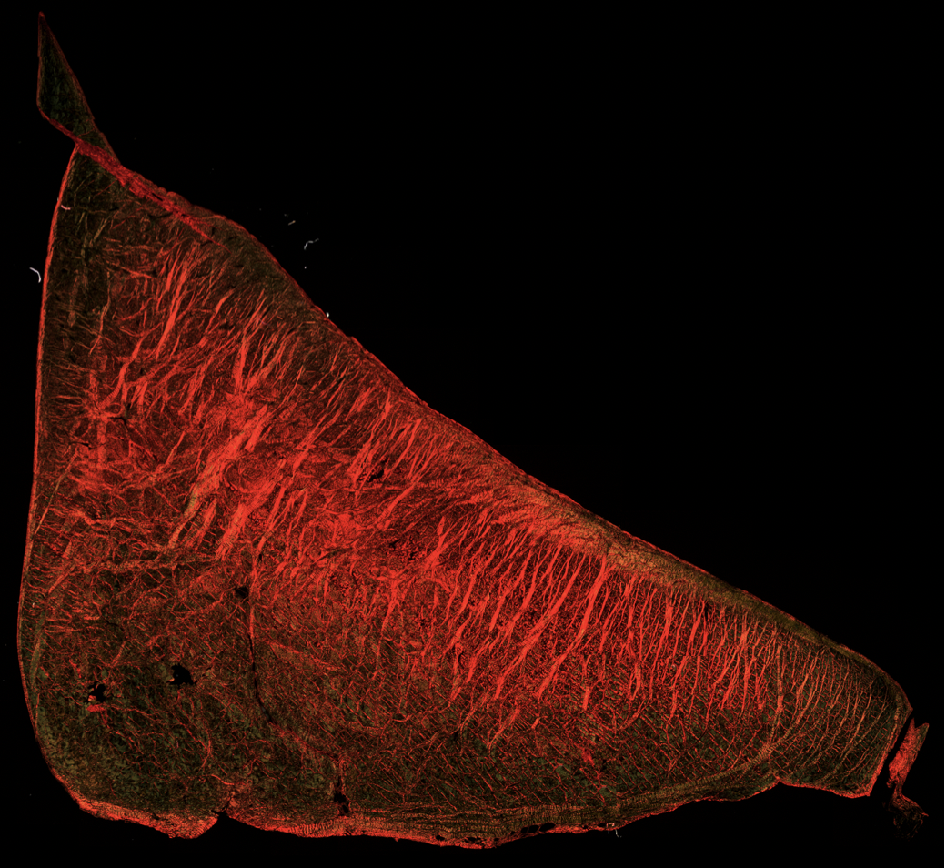
Contact: Prof. Larry Bonassar
Email: lb244@cornell.edu
Phone: 5-9381
Office: 149 Weill Hall

